ASSIGNMENT 3:
Module 4: Functions & Modules in Python
Task 1: Calculate Factorial Using a Function
Problem Statement: Write a Python program that:
1. Defines a function named factorial that takes a number as an argument and calculates its factorial using a loop or recursion.
2. Returns the calculated factorial.
3. Calls the function with a sample number and prints the output.
Expected Output:
For example, if the function is called with 5, it should return:
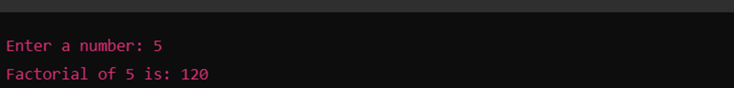
Task 2: Using the Math Module for Calculations

Problem Statement: Write a Python program that:
1. Asks the user for a number as input.
2. Uses the math module to calculate the:
o Square root of the number
o Natural logarithm (log base e) of the number
o Sine of the number (in radians)
3. Displays the calculated results.
Expected Output:
For example, if the user enters 25, the output should be:
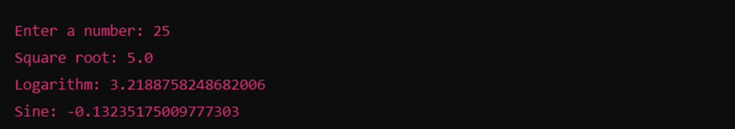
Submission Instructions:
- Create a GitHub repository and upload your Python scripts (.py files).
- Ensure the repository includes a README.md file that describes the functionality of your programs.
- Add both Task 1 and Task 2 scripts in the same repository.
- Submit the link to your GitHub repository once uploaded.

Reference:
Follow the Python course - Module 4: Functions & Modules in Python for additional guidelines and examples.

Note:
Please test your project thoroughly and check all the validations and error handling prior to ensure it works as expected before submission.
You can always connect to the mentor using the chat support option for any doubts or queries!

